Create two datasets employee and department of file type text where the columns are delimited by tab ( ‘\t’ ), and use these datasets to perform below Join operations : ● SELF JOIN ● INNER JOIN ● LEFT OUTER JOIN ● RIGHT OUTER JOIN ● FULL OUTER JOIN Share the screenshots of the commands used with its associated output

1. Self JOIN

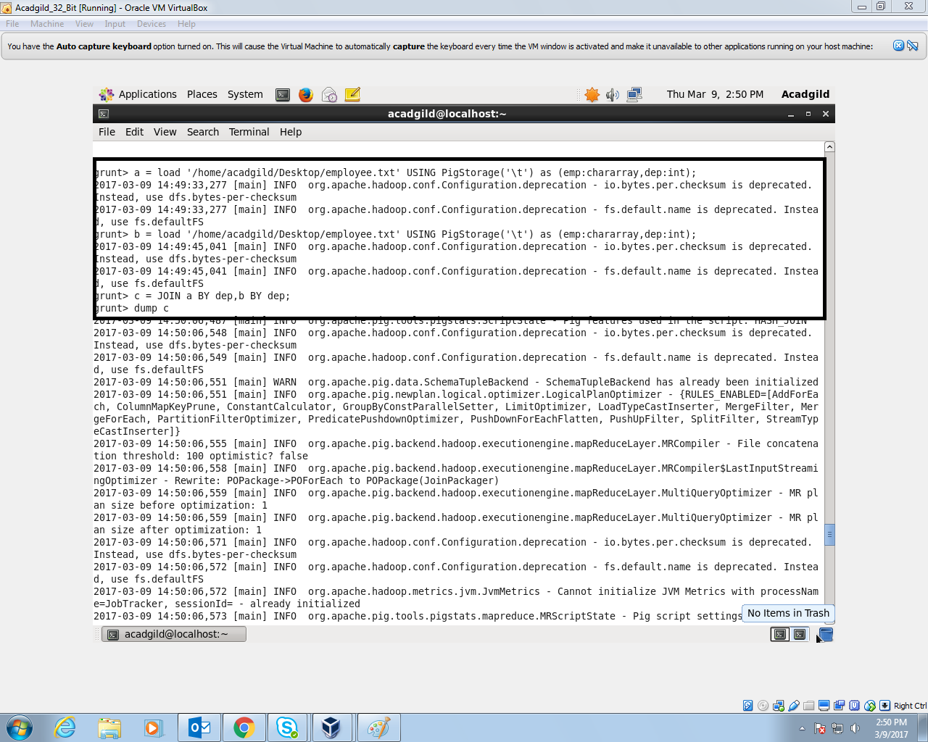

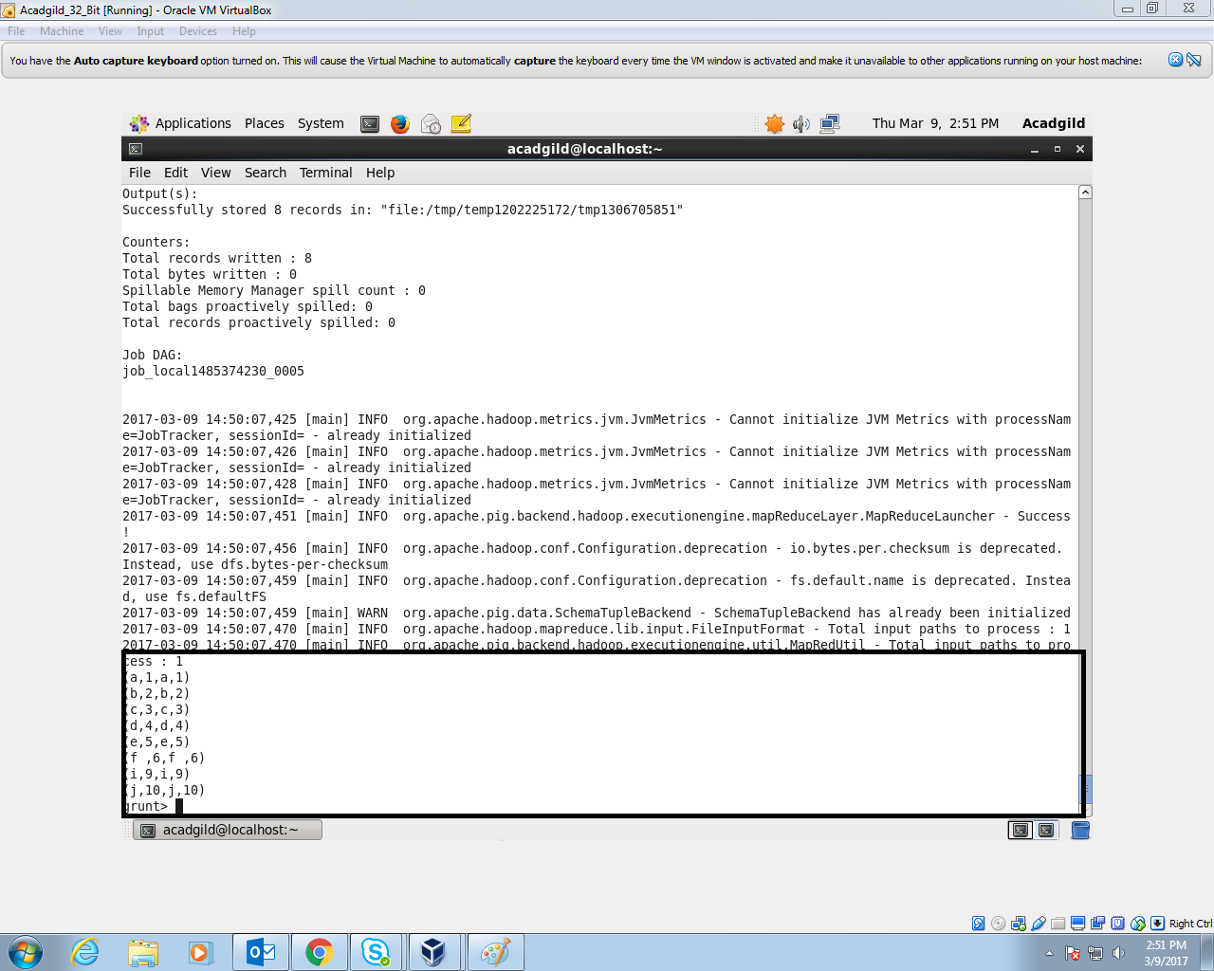

1. Inner JOIN

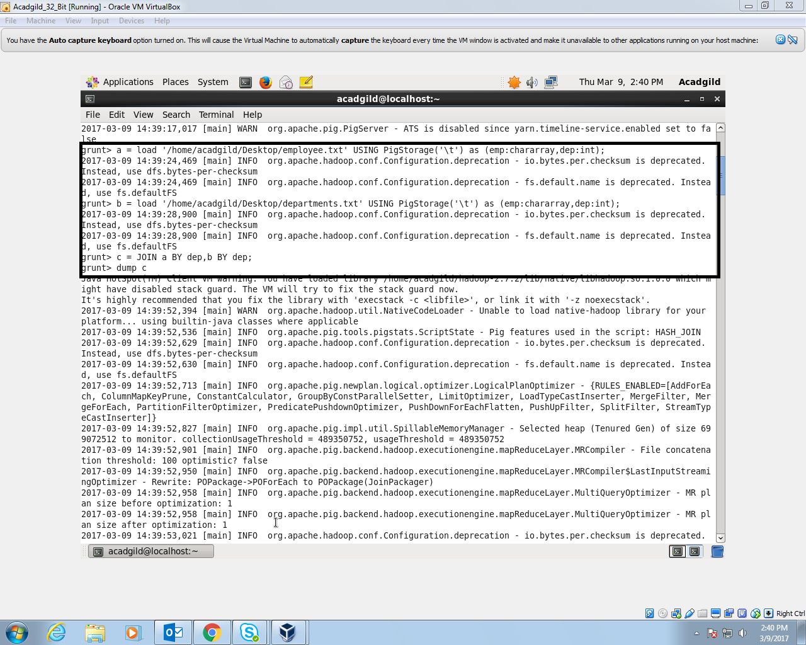

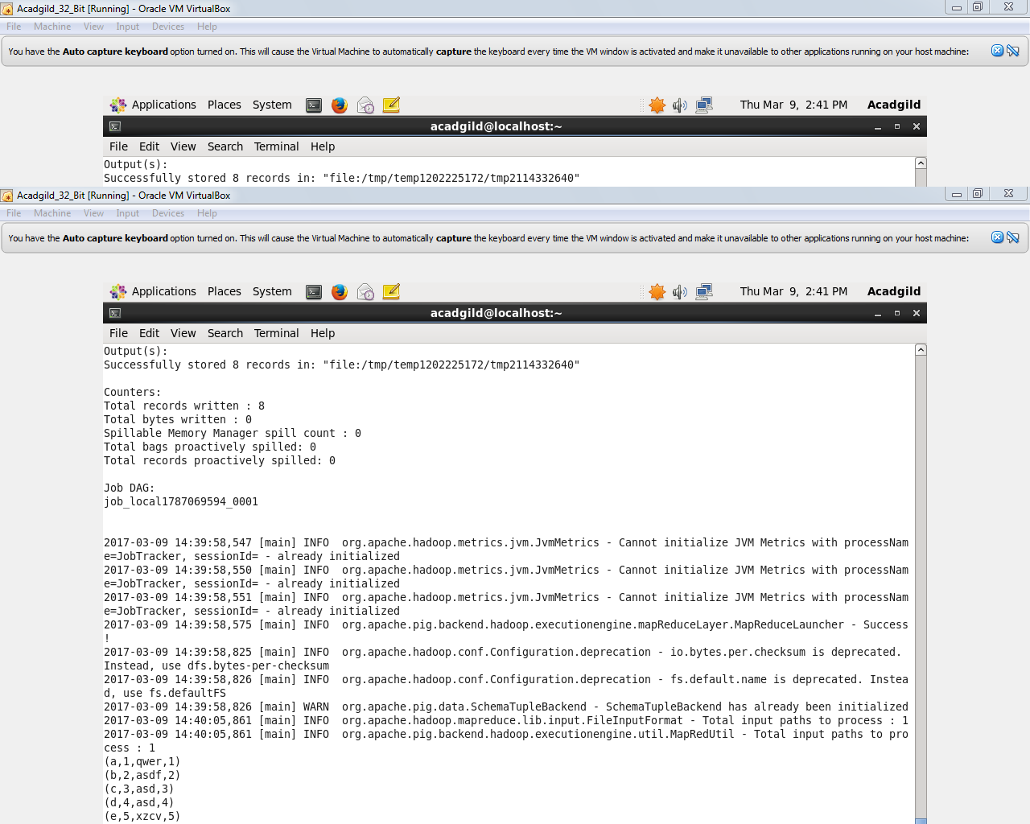

1. Left outer JOIN

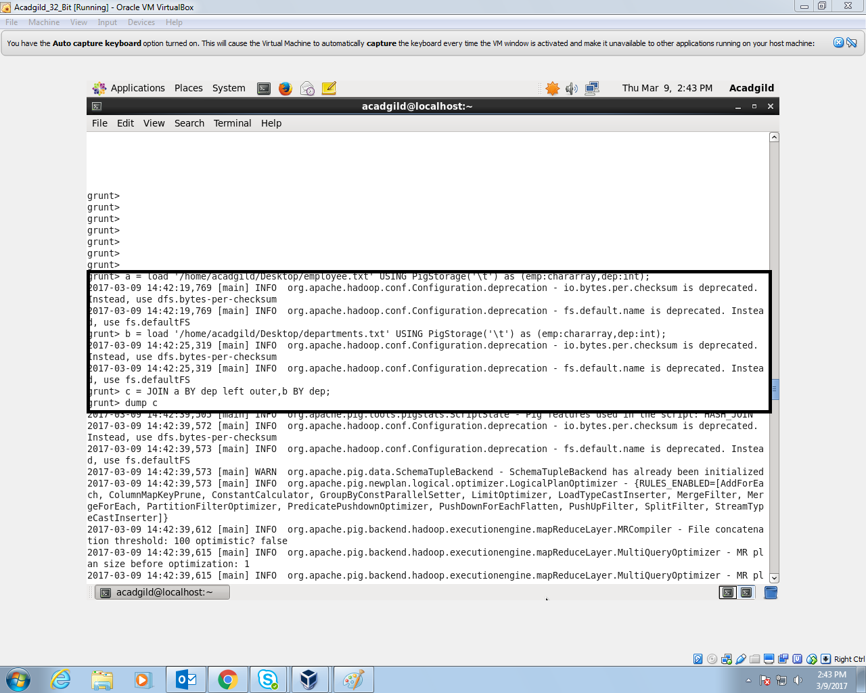

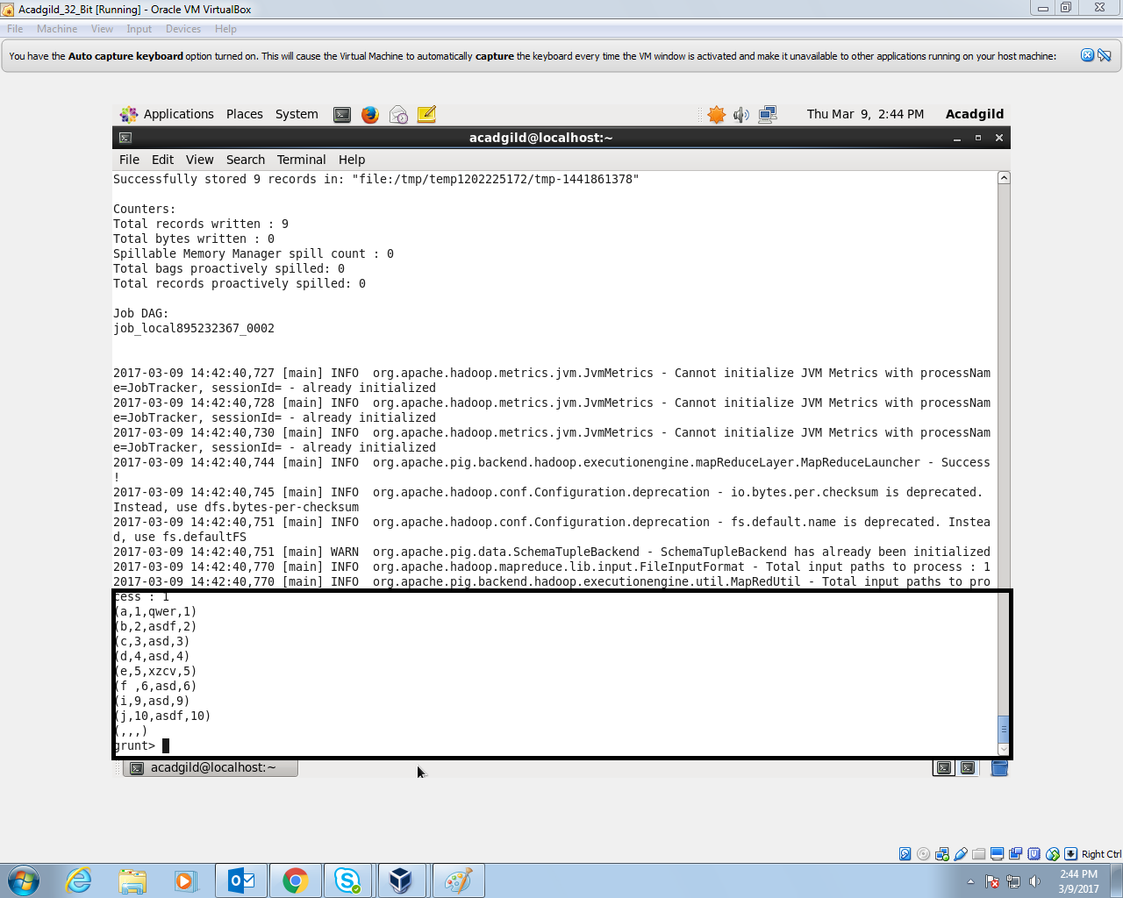

1. Right outer JOIN

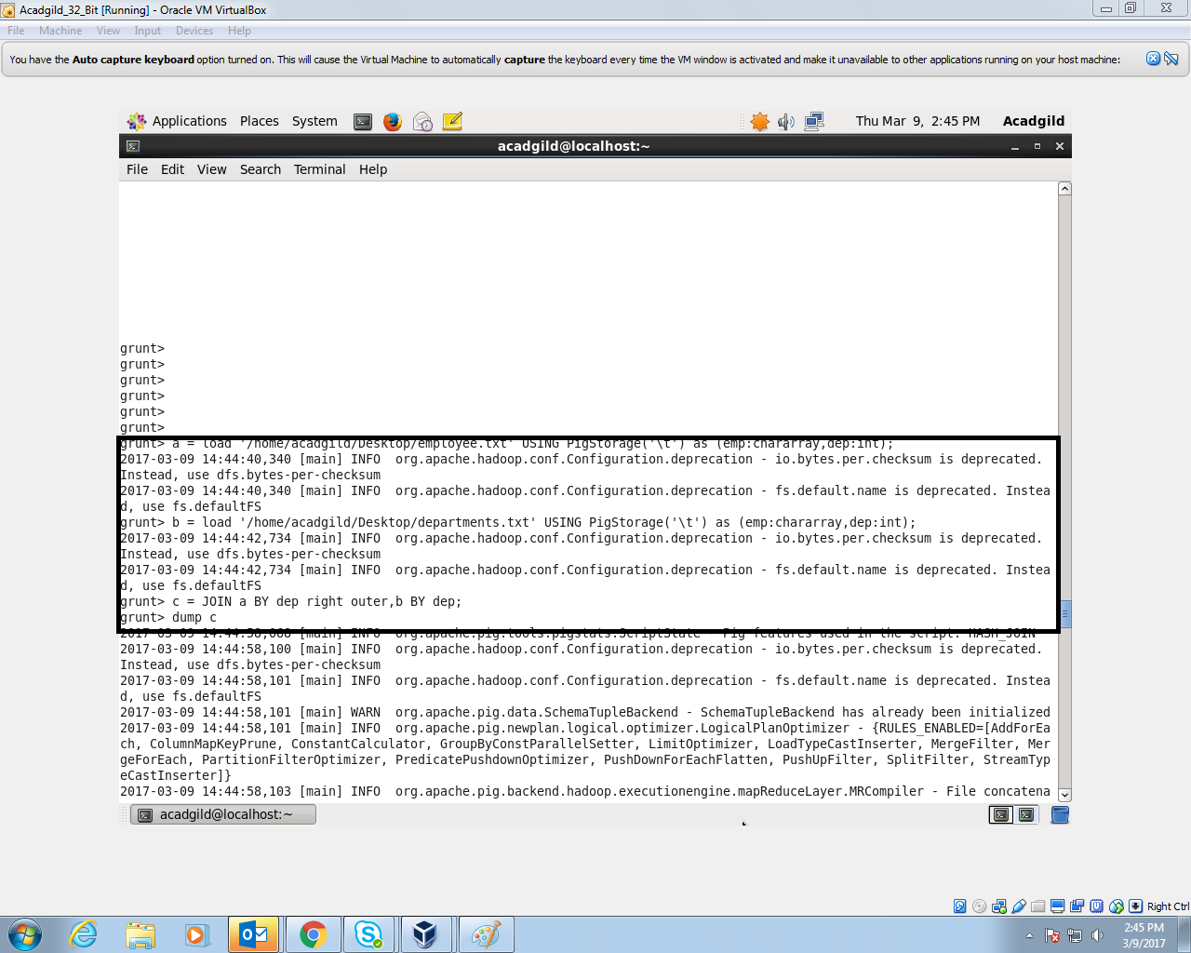

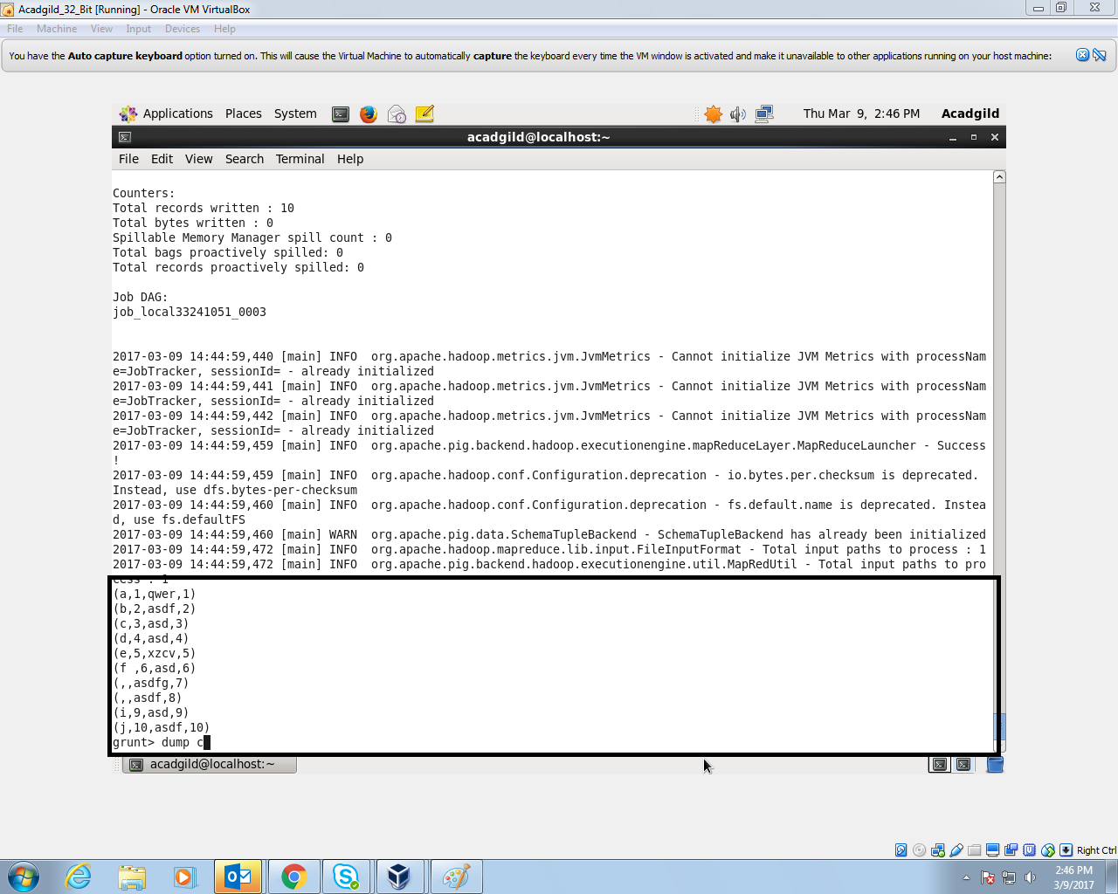

1. Full Outer JOIN

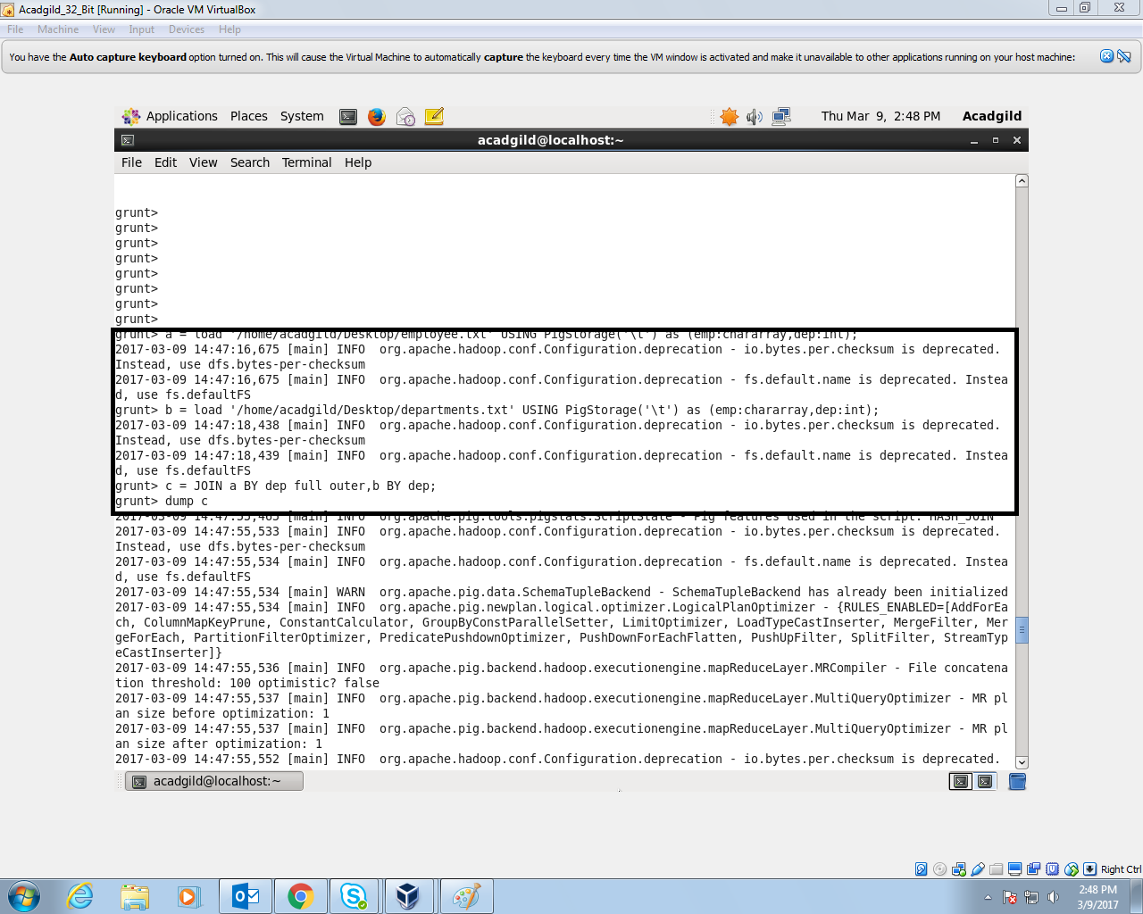

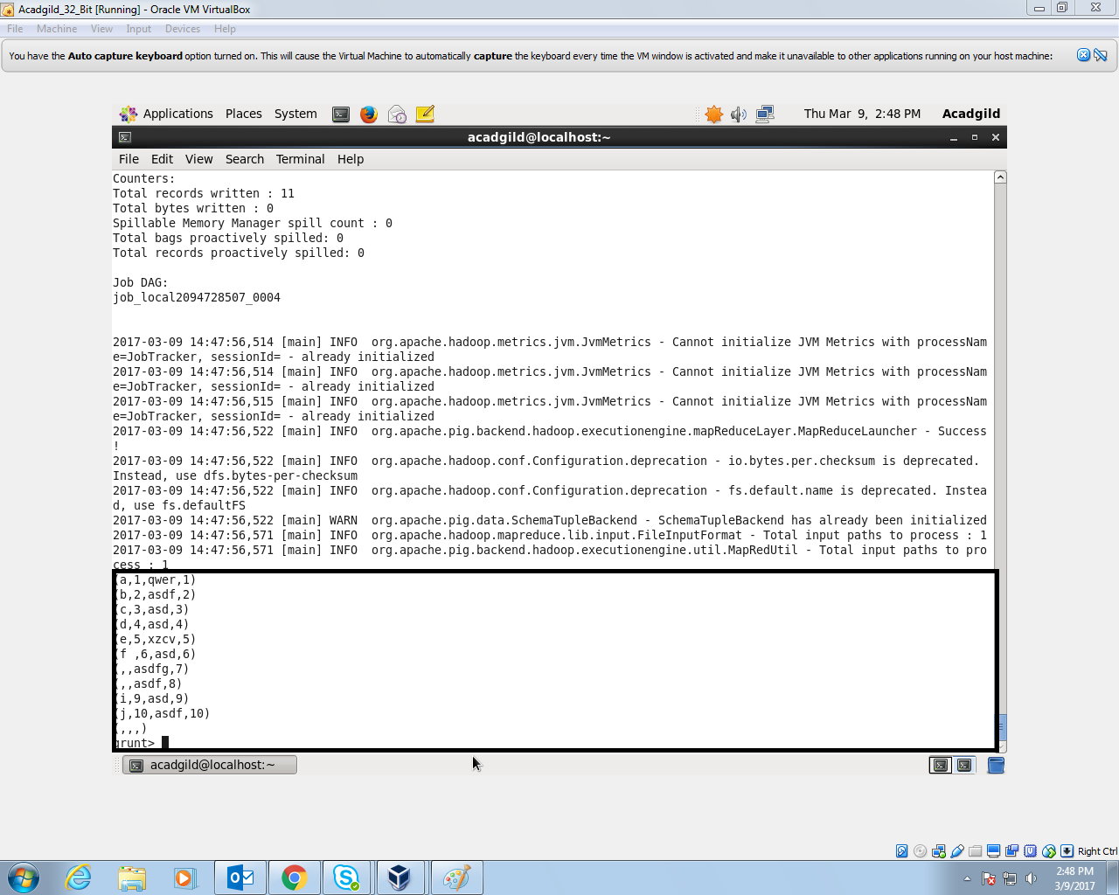

**Dataset used**

**Employee.txt**

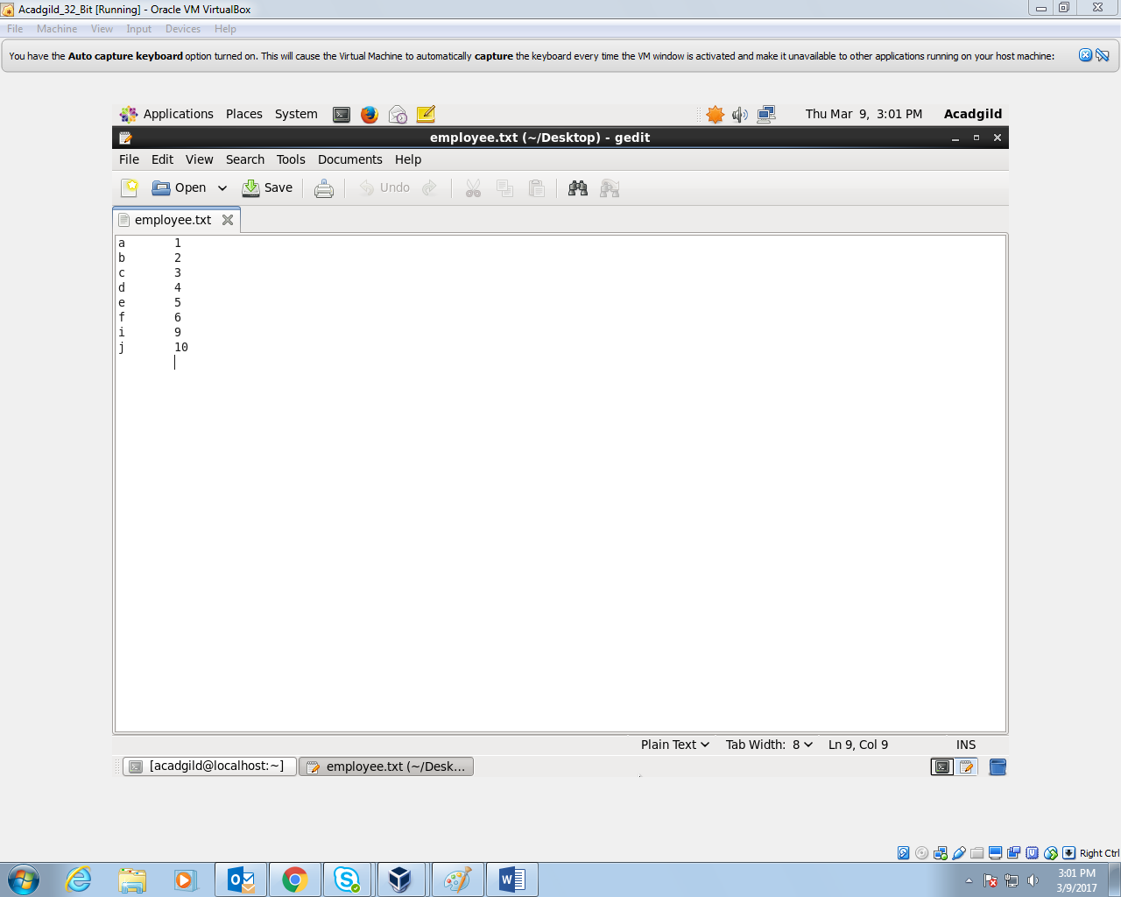

**Departments.txt**

